Chapter 1: Introduction to Human Anatomy and Physiology.

Overview of Human Anatomy and Physiology
- ____________ – the study of the structure of the body and the relationships of the various parts of the body
  - Gross or macroscopic (____________________)
  - Microscopic (___________________________)
  - Developmental – structural changes over time (_________________)
- ________________ – the study of the functions of the parts of the body, includes specific organ systems and molecular and cellular levels (neurophysiology, cardiovascular physiology, electrophysiology)

Introduction:
- The early students of anatomy and physiology were most likely concerned with treating illnesses and injuries.
- Early healers relied on _______________________________.
- Later, herbs were used to treat certain ailments.
- Eventually, after much controversy, the study of medicine with standardized terms in ____________________ began.

Levels of Structural Organization
- _______________ – atoms combine to form molecules
- _______________ – molecules interact to make up cells
- _______________ – cells are grouped into tissue
- _______________ – tissues compose organs
- _______________ – organs function together to form organ systems
- _______________ (individual) – made up of the organ systems

Basic Structures of the Human Body
- ____________ – A group of similar cells that performs a specific function
- ____________ – A structure consisting of a group of tissues with a specialized function
- ____________ – Organs working together to allow the body to perform a function.

Organ Systems
- ____________________
  - Forms the external body covering
  - Composed of skin, sweat glands, oil glands, hair, and nails
  - Protects deep tissues from injury and synthesizes vitamin D

- ____________________
  - Composed of bone, cartilage, and ligaments
  - Protects and supports body organs
  - Provides the framework for muscles
  - Site of blood cell formation
  - Stores minerals

- _____________________
  - Composed of muscles and tendons
  - Allows manipulation of the environment, locomotion, and facial expression
  - Maintains posture
  - Produces heat

- ________________________
  - Integrates and coordinates body functions
  - Composed of the brain, spinal column, and nerves
  - Is the fast-acting control system of the body
  - Responds to stimuli by activating muscles and glands

- ________________________
  - Integrates and coordinates body functions
  - Includes all glands that secrete chemical messengers, also called hormones
  - Hormones alter the metabolism of target cells
  - Examples of organs of the ES are the pituitary, thyroid, parathyroid, adrenal glands, pancreas, ovaries, testes, pineal gland, and thymus gland

- _________________________
  - Composed of the heart and blood vessels
  - The heart pumps blood
  - The blood vessels transport blood throughout the body

- __________________________
  - Composed of red bone marrow, thymus, spleen, lymph nodes, and lymphatic vessels
  - Picks up fluid leaked from blood vessels and returns it to blood
  - Disposes of debris in the lymphatic stream
  - Houses white blood cells involved with immunity

- __________________________
  - Composed of the nasal cavity, pharynx, trachea, bronchi, and lungs
  - Keeps blood supplied with oxygen and removes carbon dioxide

- __________________________
  - Composed of the oral cavity, esophagus, stomach, small intestine, large intestine, rectum, anus, and liver
  - Breaks down food into absorbable units that enter the blood
  - Eliminates indigestible foodstuffs as feces

- __________________________
  - Composed of kidneys, ureters, urinary bladder, and urethra
  - Eliminates nitrogenous wastes from the body
  - Regulates water, electrolyte, and pH balance of the blood

- ___________________________
  - Composed of prostate gland, penis, testes, scrotum, and ductus deferens
  - Main function is the production of offspring
  - Testes produce sperm and male sex hormones
  - Ducts and glands deliver sperm to the female reproductive tract

- ____________________________
  - Composed of mammary glands, ovaries, uterine tubes, uterus, and vagina
  - Main function is the production of offspring
  - Ovaries produce eggs and female sex hormones
  - Remaining structures serve as sites for fertilization and development of the fetus
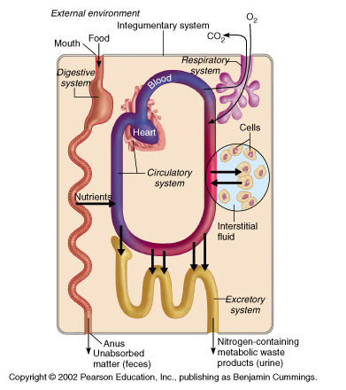
  - Mammary glands produce milk to nourish the newborn

Organ System Interrelationships
- The integumentary system protects the body from the _____________________ environment
- Digestive and respiratory systems, in contact with the external environment, take in ____________________
- Nutrients and oxygen are distributed ____________________
- Metabolic wastes are eliminated by _________________________________________

Characteristics of life include:
- _________________________ (internal or gross)
- _______________________ (reaction to internal or external change)
- _____________________ (increase in size without change in shape)
- _____________________ (new organisms or new cells)
- ____________________ (use of oxygen; removal of CO₂)
- ___________________ (breakdown of food into simpler forms)
- ____________________ (movement of substances through membranes and into fluids)
- ____________________ (movement within body fluids)
- _____________________ (changing nutrients into chemically different forms)
- _____________________ (removal of metabolic wastes)

The total of all the chemical reactions that are continuously at work to maintain these characteristics constitutes metabolism.

Metabolism-side note
- Metabolism: A broad term used for all the chemical reactions that occur within cells of the body
  - _________________ - breaking down substances into simpler components
  - _________________ – synthesizing more complex substances or structures from simpler substances

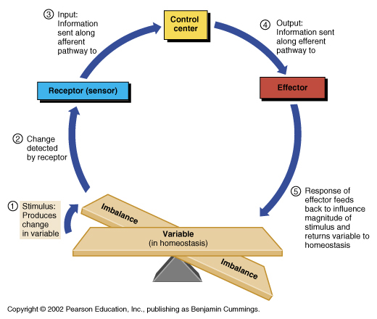
Homeostasis
- Maintenance of a stable internal environment is called homeostasis. Homeostasis is regulated through control systems that have receptors, a set point, and effectors in common. Examples include:
  - Homeostatic mechanisms regulate _______________ ___________________________________________
  - Another homeostatic mechanism employs pressure-sensitive receptors to regulate blood pressure.
- Homeostatic Control Mechanisms
  - ______________ – the factor or event being regulated
  - ______________ monitors the environment and responds to changes (stimuli)
  - ______________ determines the set point at which the variable is maintained
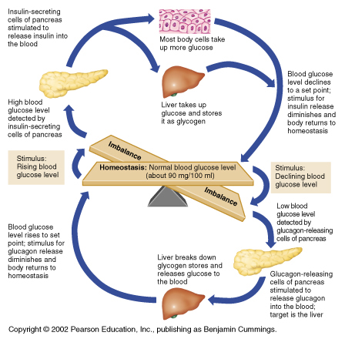
  - ______________ provides the means to respond to the stimulus

Negative Feedback

- Example: Regulation of blood glucose levels

Positive Feedback
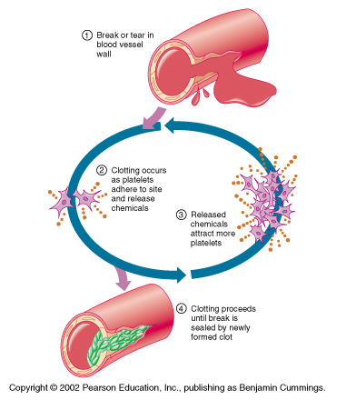

- Examples: Regulation of blood clotting, Uterine contractions during labor.

Levels of Structural Organization
- The human body is the sum of its parts and these parts can be studied at a variety of levels of organization.
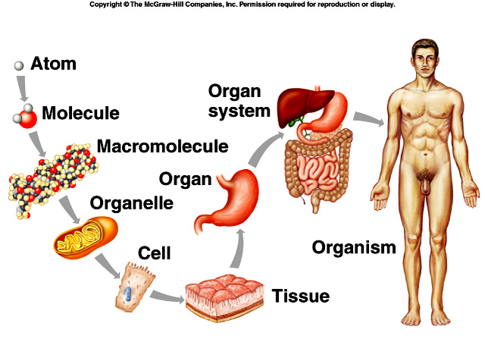
  - Atoms are the simplest level.
  - Two or more atoms comprise a molecule.
  - Macromolecules are large, biologically important molecules inside cells.
  - Organelles are aggregates of macromolecules used to carry out a specific function in the cell.
  - Cells are the basic living unit.
  - Tissues are groups of cells functioning together.
  - Groups of tissues form organs.
  - Groups of organs function together as organ systems.
  - Organ systems functioning together make up an organism.

Body Cavities
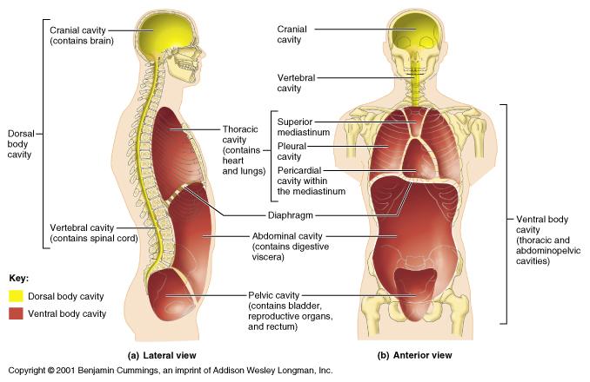
- Thoracic cavity is subdivided into pleural cavities, ____________________________________________________
  - Pleural cavities – each houses a lung
  - Mediastinum – contains the pericardial cavity, and surrounds the remaining thoracic organs
  - Pericardial – encloses the heart
- Dorsal cavity protects ________________________________________, and is divided into two subdivisions
  - Cranial cavity is within the skull and encases the brain
  - Vertebral cavity runs within the vertebral column and encases the spinal cord
- Ventral cavity houses the internal organs (viscera), and is divided into two subdivisions:________________________________________________________

Organization of the Human Body
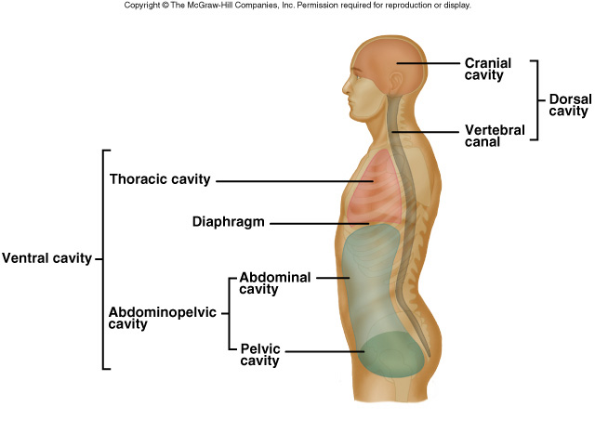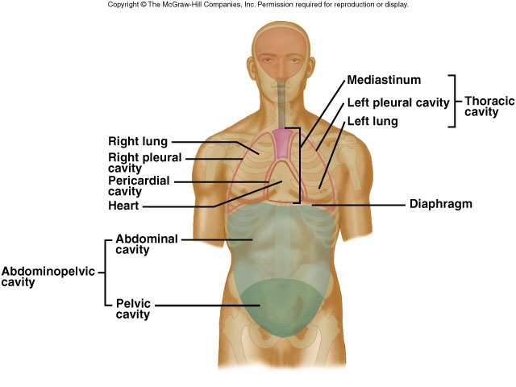
- Major features of the human body include its ______________________________________________________
  - The body can be divided into an _______________________ portion (upper and lower limbs) and an _____________________ portion (head, neck, and trunk), which includes a dorsal and a ventral cavity. Organs within these cavities are called viscera.

- Regional Terms
  - _________________ – head, neck, and trunk
  - _________________ – appendages or limbs
  - Specific regional terminology

- Regional Terms
  - The dorsal cavity can be divided into the ________________________________________
  - The ventral cavity is made up of a thoracic cavity and an abdominopelvic cavity, ___________________________________________
      - The ________________________ divides the thorax into right and left halves.
      - The _______________________________ cavity can be divided into the abdominal cavity and the pelvic cavity.
  - Smaller cavities within the head include the oral cavity, nasal cavity, orbital cavities, and middle ear cavities.

- Thoracic and Abdominopelvic Membranes:
  - The thoracic cavity is lined with _________________; the parietal pleura lines the cavities while the visceral pleura covers the lungs. A thin layer of serous fluid separates the two layers.
  - The heart is surrounded by _____________________. The visceral pericardium covers the heart and the parietal pericardium makes up an outer sac. Serous fluid separates the two layers.
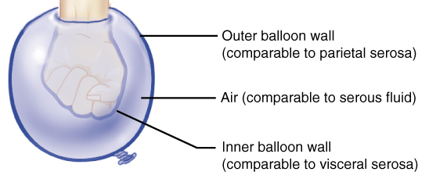
  - _________________________ lines the abdominopelvic cavity; a parietal peritoneum lines the wall while visceral peritoneum covers the organs.

- Ventral Body Cavity Membranes
  - Parietal serosa covering the body walls
  - Visceral serosa covering the internal organs
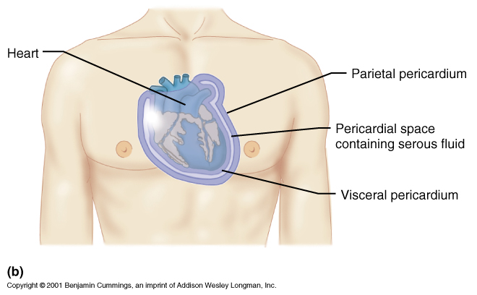
  - Serous fluid separates the serosae
  - Parietal Pleura - pleura lining the inner chest walls and covering the diaphragm
  - Visceral Pleura - pleura covering the lungs
  - Peritoneum – the serous membrane lining the abdominal cavity and covering most of the viscera

- Nomenclature for Serous Membranes
  - ______________________________ - the thin serous membrane around the lungs and inner walls of the chest
  - _______________________ – the serous membrane lining the abdominal cavity and covering most of the viscera
  - _____________________ - the membrane that lines the cavities of the heart and forms part of the heart valves
  - ________________ - a double-layered serous membrane that surrounds the heart
  - _______________________ (epicardium) - the innermost of the two layers of the pericardium
  - ______________ - the tough outermost layer of the pericardium that is attached to the diaphragm and the sternum

Organ Systems:
- __________________________________
  - The integumentary system, including skin, hair, nails, and various glands, covers the body, senses changes outside the body, and helps regulate body temperature.
- ___________________________________
  - The skeletal system is made up of bones and ligaments. It supports, protects, provides frameworks, stores inorganic salts, and houses blood-forming tissues.
  - The muscular system consists of the muscles that provide body movement, posture, and body heat.
- ______________________________________
  - The nervous system consists of the brain, spinal cord, nerves, and sense organs. It integrates incoming information from receptors and sends impulses to muscles and glands.
  - The endocrine system, including all of the glands that secrete hormones, helps to integrate metabolic functions.
- ___________________________________
  - The cardiovascular system, made up of the heart and blood vessels, distributes oxygen and nutrients throughout the body while removing wastes from the cells.
  - The lymphatic system, consisting of lymphatic vessels, lymph nodes, thymus, and spleen, drains excess tissue fluid and includes cells of immunity.
- ____________________________________
  - The digestive system is made up of the mouth, esophagus, stomach, intestines, and accessory organs. It receives, breaks down, and absorbs nutrients.
  - The respiratory system exchanges gases between the blood and air and is made up of the lungs and passageways.
  - The urinary system, consisting of the kidneys, ureters, bladder, and urethra, removes wastes from the blood and helps to maintain water and electrolyte balance.
- _______________________________________
  - The reproductive system produces new organisms.
    - The male reproductive system consists of the testes, accessory organs, and vessels that conduct sperm to the penis.
    - The female reproductive system consists of ovaries, uterine tubes, uterus, vagina, and external genitalia. The female reproductive system also houses the developing offspring.

Anatomical Terminology
- Relative Positions:
  - Terms of relative position are used to describe the _____________________ of a part relative to another part.
  - Terms of relative position include: superior, inferior, anterior, posterior, medial, lateral, proximal, distal, superficial (peripheral), and deep.

- Directional Terms
  - _____________ (Cranial) and _____________ (Caudal) – toward and away from the head or upper part of a structure - above and below-
  - ____________ (Ventral) and ______________ (Dorsal) – toward the front and back of the body - in front of and behind-
  - _____________________________________ – toward the midline, away from the midline, and between a more medial and lateral structure
  - _____________________________________ – closer to and farther from the origin of the body part or the point of attachment of a limb
  - ________________ (External) and ________ (Internal) – toward and away from the body surface

- Body Sections:
  - A sagittal section divides the body into right and left portions.
  - A transverse section divides the body into superior and inferior portions. It is often called a “cross section”.
  - A coronal section divides the body into anterior and posterior sections.
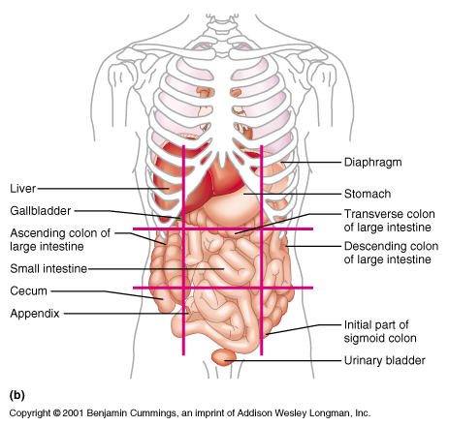
- Abdominopelvic Regions
