Introduction
Architectural Pattern of an Animal Symmetry
I. Body Plan
A. Symmetry = correspondence in size and shape of parts on opposite sides of a median plane
a. _______________________ = parts of body are arranged concentrically around oral/aboral (top and bottom) axis, +2 plane through ____________________ axis results in mirrored halves
    - tubular appearance, no front or back, sessile (does not move) or free floating
    - hydra, jellyfish, sea urchin, adult sea star (bilateral larvae)
    - Radiata (Cnidaria, Ctenophora)
    - not ______________________________________________

B. bilateral symmetry = cut along sagittal plane divides animal into _________________________(left, right)
a. better adapted for directional mvmt
b. monophyletic ________________________________________________
c. associated w/ cephalization (differentiation of head)
      - well-suited for sensing/responding to environment
d. terms associated w/ bilaterally symmetrical animals
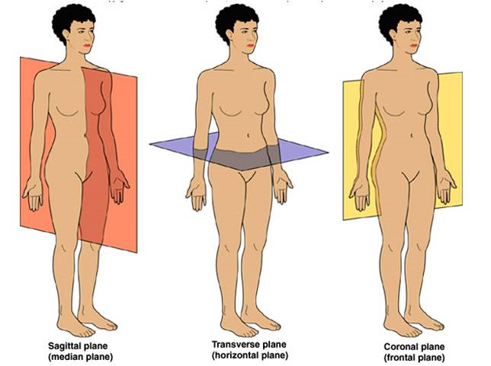
      - anterior =
      - posterior = tail end
      - dorsal =
      - ventral =
      - medial = midline
      - lateral =
      - distal = far from
      - proximal =
      - frontal plane = divides body into dorsal and ventral halves
      - saggittal plane = divides body into right and left sides
      - transverse plane (a.k.a. cross section) = divides body into anterior and posterior ends
      - pectoral =
      - pelvic = hip region,

Scientific Classification : Dam King Philp Came Over From Great Spain

How about humans????? Domain Eukarya
  - Kingdom Animalia
    - Phylum Chordata
      - Subphylum Vertebrata
        - Class Mammalia
          - Order Primates
            - Family Hominidae
              - Genus Homo
                - Species sapien sapiens
II. Subkingdom: Parazoa
A. Phylum Porifera

Are Sponges animals or plants????

a. Sponges are essential animals that appear so sedate to the human eye that ancient Greeks believed them to be PLANTS.

b. Sponges are an ancient group with an extensive fossil record that dates back to the early Precambrian period, about ____________________ years ago. The name Porifera, pore bearer, aptly describes the body of the sponge, which consists of a bag pierced by many pores and canals.
c. Characteristics of Parazoas
- _____________________________________
- Primarily marine; some 100 live in freshwater. Range in height ________________________.
- Lack true tissues (apoblastic) and organs but have specialized cells. ____________________.
- If a sponge was __________________, its cells would break apart and then flow back together again, reforming the sponge on the other side.
- Nearly all sponges are suspension feeders (filter feeders), which are animals that collect food particles from water passed through some type of food-trapping equipment.

d. Sponges trap food from the water by:
1. Beating collar cells produce water currents that flow through pores in sponge wall into a central cavity and out through an ___________________, the upper opening.
2. Water is drawn through the pores into the central cavity, the spongocoel (spŏng'gə-sēl').
3. Then flows out of the sponge through a larger opening called the osculum.

- Asexual and sexual reproduction. Most sexually reproducing are _______________________ (Hermes-the god and Aphrodite-the goddess) and produce eggs and sperm at different times. The larval stage is able to move about while the adult is stationary.
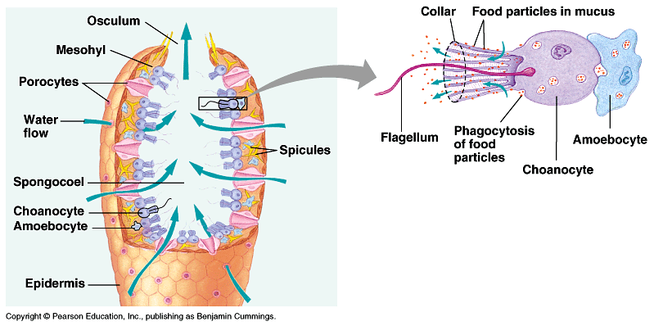
- There are _________________________ in sponges: merely specialized cell layers. Epidermal cells in sponges line the outer surface.
III. Subkingdom: Eumetazoa (yū'mĕt'əzō'ə) True tissue

Radiata-Radial symmetry; diploblastic

Phylum Cnidaria

A. Phylum Cnidaria-Radiata-Radial symmetry; diploblastic
B. Cnidarians are characterized by stinging cells called nematocysts or cnidocysts:
  - When disturbed eject a _________________________ and often poison as well.
  - Touching the trigger of the cnidocyte, the nematocyst is discharged.
  - Injecting ________________________. See Figure 33.4
C. Cnidaria characteristics
a. Cnidarians are aquatic animals usually found in warm marine habitats and some are found in freshwater habitats.
  - Ex __________________________________________
b. Fossil records go back more than ______________________________.
c. Many of these organisms harbor ________________________ algae within their cells, which allow them to thrive in nutrient poor waters. The algae produce some sugars useful to cnidarians, and the cnidarians provide protection for the algae. Develop Coral reefs by secretions.
  - Cnidarians are diploblastic (dĭp'lō-blăs'tĭk)-epidermis and gastrodermis; radial symmetry.
d. Cnidarians have only the ectoderm and endoderm tissue layers. Sessile forms are polyp and free-floating called medusa. Two main body forms: _________________________________________.

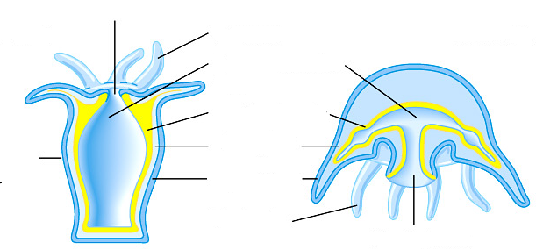

C. Two body forms occur: a mobile ________________and a sessile (not mobile) _____________________.
a. Both forms have tentacles arranged around an opening.
b. The inner tissue layer (derived from endoderm) secretes digestive juices into the gastrovascular cavity, which digests food and circulates nutrients.
Side Note:
Cnidarians have both muscle fibers and nerve fibers (simplest forms), making these animals capable of directional movement.
A nerve net allows transmission of messages in more than one direction, possibly an advantage in a radially symmetrical animal, while contraction of muscle fibers (under control of the nerve fibers) allows for movement.
- Muscle fibers occur at the base of the epidermal and gastrodermal cells.
- Nerve cells (BUT NO BRAIN) located below epidermis near the mesoglea interconnect and form a nerve net throughout the body.
D. Reproduction-Life cycle
a. Cells are organized into tissues. The typical cnidarian life cycle involves both sexual and asexual reproduction.
i.

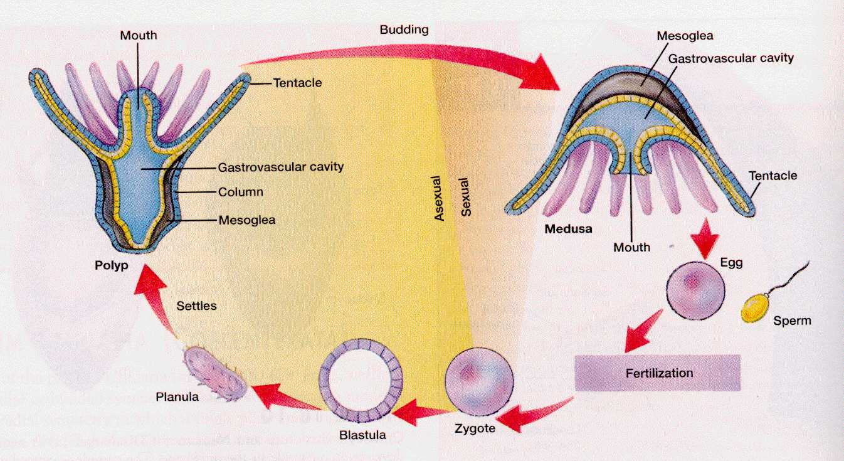
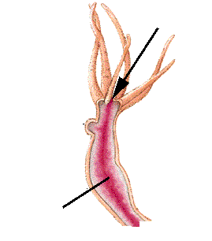
See figure 33.6- Hydras and Portuguese Man-of-War
b. Gastrovascular cavity used for digestion. Has single opening;
often surrounded with tentacles. See Figure
  - What happens to the waste products?

IV. Subkingdom: Eumetazoa (yū'mĕt'əzō'ə) True tissue
- Bilateria-bilateral symmetry; triploblastic
- Acoelomates no body cavity
A. Phylum: Platyhelminthes
a. Contains about 13,000 species of flatworms subdivided into three classes: two parasitic and one free- living
b.
c.
d.
B. Three different Classes of Flat Worms Eumetazoa-
True tissue
a. _____________________ Flatworms (ex Planarians) nonparasitic and carnivores that prey on smaller animals; rely on diffusion for movement of oxygen, food and nitrogen wastes; are free-living and mostly; asexual and sexual reproduction.
    - The animal captures food by wrapping itself around prey, entangling it in slime, and pinning it down. The pharynx is a muscular tube that extrudes from the mouth and through which food is ingested.
    - The flame cell system functions in excretion and consists of a series of interconnecting canals that run length of the body on either side of the longitudinal axis.
b. ______________________: Flukes (ex Liver flukes), live as parasitic in or on other animals; hermaphroditic, eggs fertilized in host then shed in feces-larva continues development in secondary host (snail); 200 million people around the are infected with blood flukes-body pain, anemia, and dysentery.
c. _____________________: Example Tapeworms; are parasitic, adults live mostly in vertebrates, including humans; a tapeworm’s head (scolex) is armed with suckers and hooks that lock the worm to the intestinal lining of the host.
    - Posterior to the head is a long ribbon of units called proglottis (prō-glŏt'ĭd), which are sacs of sex organs (packed with gametes).
    - Life cycle: Eggs shed in feces (contaminated by humans) of the host (such as pigs and cattle) into water where they enter secondary host to form larva. Embeds in meat of secondary host (beef/pork) and then passed back to humans through infected meat!
    - Lack a digestive tract, the tapeworm absorbs food predigested by the host.
Read Additional Side Notes:
The phylum as a whole has adult bilateral symmetry and cephalization (the development of a head with sensory organs, in most members).
- Flatworms have three tissue layers: ectoderm, mesoderm and endoderm and a body plan that is acoelomate and sac-like with a single opening.
  - The mesoderm layer gives rise to muscles and reproductive organs. Free living forms have muscles, a nerve cord, and digestive organs, but lack both the respiratory and circulatory systems common to the "higher" animals.
  - Flatworms have a branched gastrovascular cavity that is the site of extracellular digestion and which distributes nutrients throughout the body. Gas exchange occurs by diffusion through the skin.
- Platyhelminthes have an excretory system that also functions as an osmotic-regulating system. Flatworms have ladder-style nervous system composed of paired ganglia that form a brain connected via nerve cells to sensory cells in the body wall.
