Chapter 24: The Fishes: Vertebrate Success in Water
- Phylum Chordata
- 5 hallmark characteristics-
- Evolutionary Evidence
- Hagfish are the most primitive living craniates.
- 2 Key craniate characteristics is: ____________________ and_________________________
- 530 million years ago possible fossil with brain
- 500 million years ago bone well developed in group of fishes called __________ (bony armor)
- First vertebrates probably marine
- Vertebrates did _____ ___________________and much of the evolution of fish occurred there.
- Early vertebrate evolution involved the movement of fishes back and forth between marine and freshwater environments.
- The importance of freshwater in the evolution of fishes is evidenced by the fact that over _____ __________________________ even though freshwater habitats represent only ________ ___________________________________ of the earth’s water resources.
- Super Class Agnatha – Living Jawless Fish
- Head-supported by cartilaginous bars
- Brain- enclosed in fibrous sheath
- _________________
- Retain notochord (axial supportive structure)
- 4 pairs of sensory tentacles surrounding their mouths
- Ventrolateral slime glands
- Composed of classes Myxini and Petromyzontida

- Class Myxini
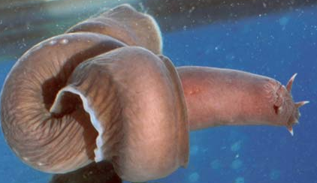
- Example: Hagfish
- Found: _______________________
- Feed on: soft bodied invertebrates or scavenge on dead or dying fish
- To provide leverage, the hagfish ties a knot in its tail and passes it forward to press against the prey
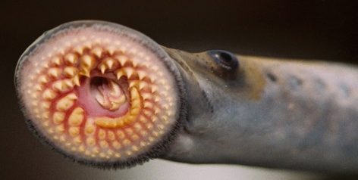
- Subphylum Vertebrata: _______________ that surrounds a ______________and serves as the primary axial support. Most vertebrates are members of the ____________________
- Class Petromyzontida Petros- stone, myzon-sucking
- Example: Lampreys
- Live in ______________________________
- Larva stage - filter feeders
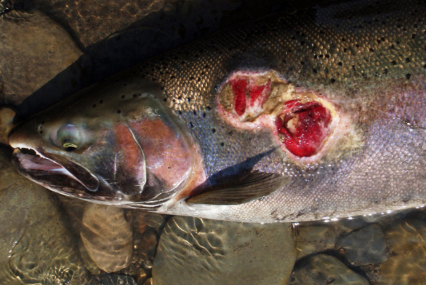
- Adult stage - prey on fish
  - Mouth –__________ with lips for attachment functions
- Attach to prey with ______________
- Use tongues to rasp away scales
- Salivary glands with ______________; feed on blood

Sea lamprey Reproduction and life-cycle:
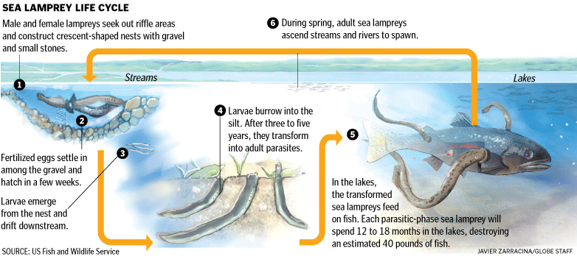

Body parts of fish

Body parts of a typical fish – draw in and fill in function below.
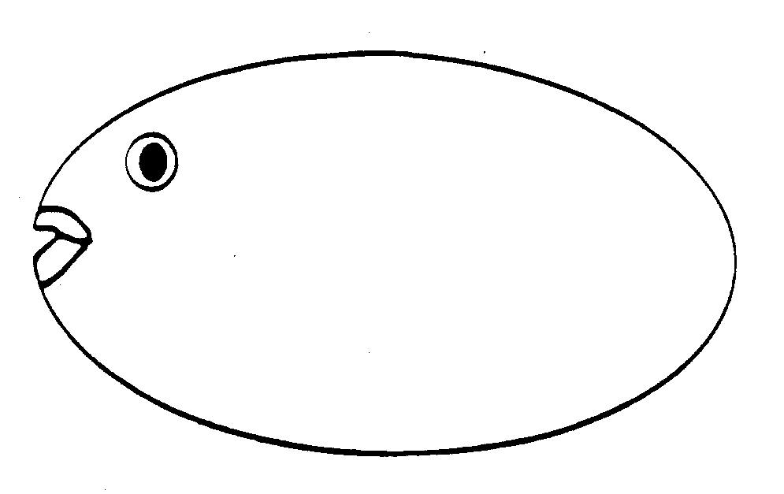

- Caudal Fin-
- Dorsal Fin-
- Anal Fin-
- Pectoral Fin-
- Pelvic Fin-
- Spines-
- Operculum-
- Lateral Line-
- Class Chondrichthyes Chondro- cartilage, ichthyes- fish
- Sharks, skates, rays, ratfish
- ______________________________
- Most marine
- Class Chondrichthyes
- Biting mouthparts
- Paired appendages
- ______________________________(gives skin tough, sandpaper texture)
- Cartilaginous endoskeleton
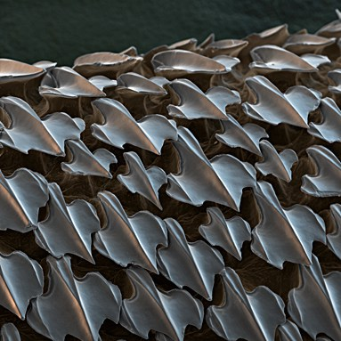
- Placoid scales
- Shark teeth are ________________ ______________________________
- Rows of teeth
  - As outer teeth wear out, newer teeth move into position from inside jaw and replaces them
- Largest living sharks?
- Filter feeders- whale shark
  - Pharyngeal-arch modifications that strain plankton

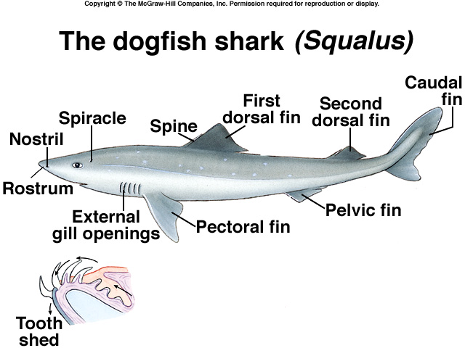

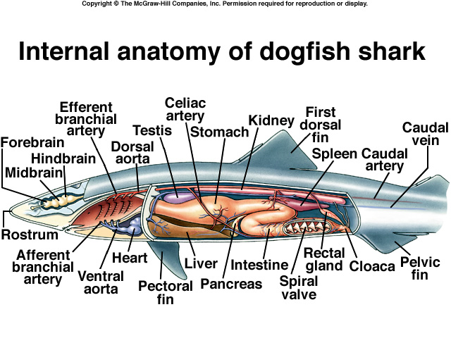

- Subclass _________________ elasmos- plate metal, branchia- gills
- Sharks, skates, rays
- 820 species
- Life on the ocean floor in shallow waters
- Wing like appendages
- Camouflage
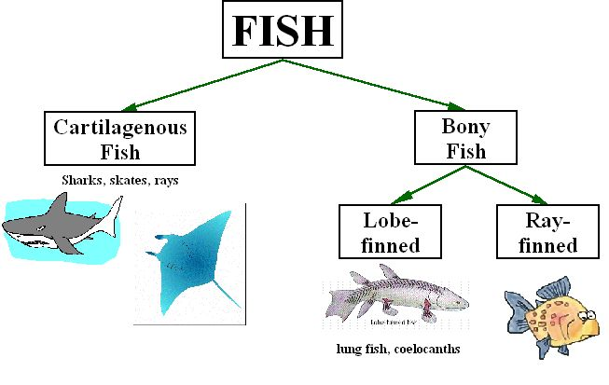
- Osteichthyes (NOT a class but a large grouping) Osteo- bone, ichthyes- fish
- ________________________________________
- Bony operculum covering the gill openings
- Lungs or swim bladder

- Class Actinopterygii Actin- ray, pteryx-fin
- Ray-finned fishes because their fins ______________________________
- __________________-gas-filled sacs along the dorsal wall of the body cavity that regulates buoyancy

- What is the largest successful vertebrate group? _______________
- Adapt to environment
- Extract oxygen from small amounts of oxygen per unit volume
- Efficient locomotor structures
- _____________________________
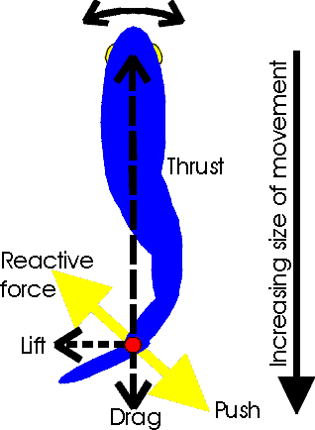
- Efficient reproduction (produces overwhelming number of offspring)

- Locomotion
- Stream line shape
- _________________ lubricates body to decrease friction between fish and water
- Use fins and body wall to push against water.
- The trunk and tail musculature propels a fish.
- Muscles are arranged in _________________ called myomeres; they have the shape of a W on the side of the fish.
- Internally the bands are folded and nested; each myomere pulls on several vertebrae.

- Nutrition and Digestion
- Most are predators (always searching for food)
  - Invertebrates, vertebrates
  - ________________________________
  - Capture prey: suction-closing the opercula and rapidly opening mouth
- Some filter feeders- _____________: trap plankton while the fish is swimming with mouth open.
- Some herbivores and omnivores

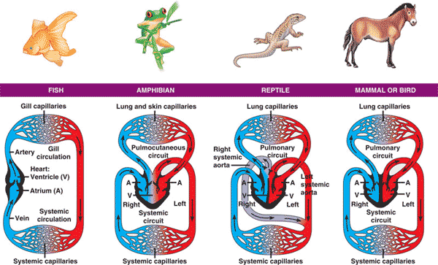
- Circulation and Gas Exchange
- The heart only has _______________
- Fish heart only pumps blood in one direction
- The blood enters the _________ through a _____________
- Exits through a vein on its way to the_____________.
- In the gills, the _____________ _____________________ from the surrounding water and leaves the gills in ________________, which go to the body.
- The _________________in the body and goes ______________.
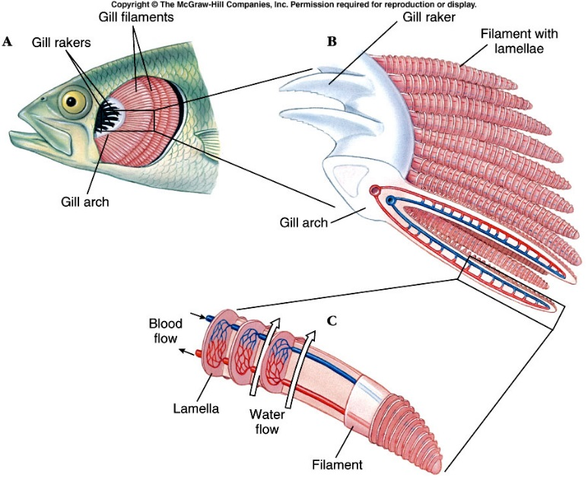
- A very simple closed-circle circulatory system.

- The gills
- the gills are composed of
  - ________________ (which gives the gill rigid support),
  - _________________ (always paired)
  - ________________ (where gas exchange takes place)
- Circulation and Gas Exchange
- The blood flows thorough the gill filaments and secondary lamellae in the __________ __________from the water passing the gills.
- This is very important for getting all of the available oxygen out of the water and into the blood
- The countercurrent exchange system
  - Provides very efficient gas exchange by maintaining a concentration gradient between the blood and the water over the entire length of the capillary bed.
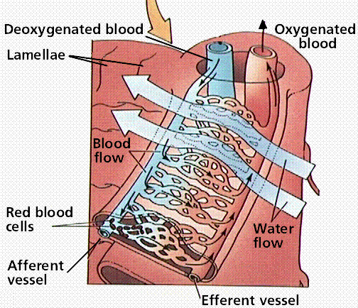
- Circulation and Gas Exchange How do fish ventilate their gills?
- Fish must pass new water over their gills continuously to keep a supply of oxygenated water available for diffusion.
- Fishes use two different methods
  - ______________________________
  - ______________________________
- Swim through the water and open your mouth (_______________________)
  - include the great white shark, the mako shark, the salmon shark and the whale shark , tuna
- _____________-help to maintain buoyancy in the water.
  - a sac inside the abdomen that contains gas.
- Four Ways Fishes Can Maintain their Vertical Position
- ONE: Fishes are saturated with ______________________. (especially in liver)
- TWO: Use their fins to ___________.
- THREE: Reduction of heavy tissues. (bones less dense, cartilaginous skeletons)
- FOUR: Swim bladder.

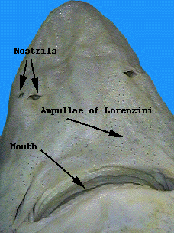
- Nervous and Sensory Functions
- Has a brain and a spinal cord
- ____________________– in snouts of fishes lead to olfactory receptors
  - Salmon and lampreys return to streams they were spawned from due to the odors
- ___________ – lidless with round lenses; focus by moving lens forward or backward
- ________________– equilibrium, balance, hearing (similar to other vertebrates)
- ___________________– sensory pits in epidermis detect water currents (from predators) or low frequency sounds
- _________________ – detection of electrical fields that the fish or another organism generates
  - Highly developed in the rays and sharks
- ______________________– currents circulate from electric organs in fish’s tail to electroreceptors near its head
  - an object in the field changes the pattern
  - Live in murky fresh waters in Africa or Amazon basin in South America
  - EX: electric eel (bony fish)
    - Shocks in excess of 500 volts
  - EX: electric ray (an elasmobranch)
    - Pulses of 50 volts
- Excretion and Osmoregulation
- _____________________________- maintain proper balance of electrolytes (ions) and water in their tissues
- _____________- excretory structures in the kidneys that filter blood borne nitrogenous waste, ions, water, and small organic compounds across a network of capillaries called: ________________
- Filtrate passes to a _______________ essential components are absorbed into blood filtrate remaining- is excreted
- Freshwater Fishes
- Never drink!
- Only take in water when eating.
- Numerous nephrons with _______________glomeruli and SHORT tubule systems
  - Little water reabsorbed
- Large quantities of diluted urine
- Active transport of ions into blood
  - Get salt in their food

- Marine Fishes
- Must combat water LOSS
  - 3.5% ions in environment 0.65% ions in tissues
- Drink water
  - Eliminate excess ions by excretions, defection, and active transport across gill.
- Nephrons -___________ glomeruli and LONGER tubule systems
  - Water absorbed from nephrons

- Reproduction and Development
- ____________________________- Lay undeveloped eggs, External fertilization (90% of bony fish), Internal fertilization (some sharks and rays)
  - fish lay huge numbers of eggs; a female cod may release 4-6 million eggs.
- ________________________- Internal development- without direct maternal nourishment-Advanced at birth (most sharks + rays)-Larval birth (some scorpeaniforms-rockfish)
- _______________________- Internal development- direct maternal nourishment -Fully advanced at birth (some sharks, surf perches)

